

# LAB – FILE

**Graphics and Animation Tools - Lab**

**CSGG 4101**

Name – Rishank Gupta

Roll No. – R100217062

Sap id – 500062486

Course – B. Tech CSE-OSS

Batch – 2

*Under the guidance of…*

Dr.Durgansh Sharma

Associate professor

Department of Cybernetics

School of computer Science (Socs)

**Experiment- 4**

**Aim: - Design your own animation using GIMP.**

**Steps taken for Animation Design**

**Step1:** In the process of a creation of simple animation in GIMP, first we need to procure images which can be made into GIF or create them using Paint.

**Step2:** Open GIMP, and go to **File> Open as Layers> and** open all the pictures as layers, ordered in chronological order.

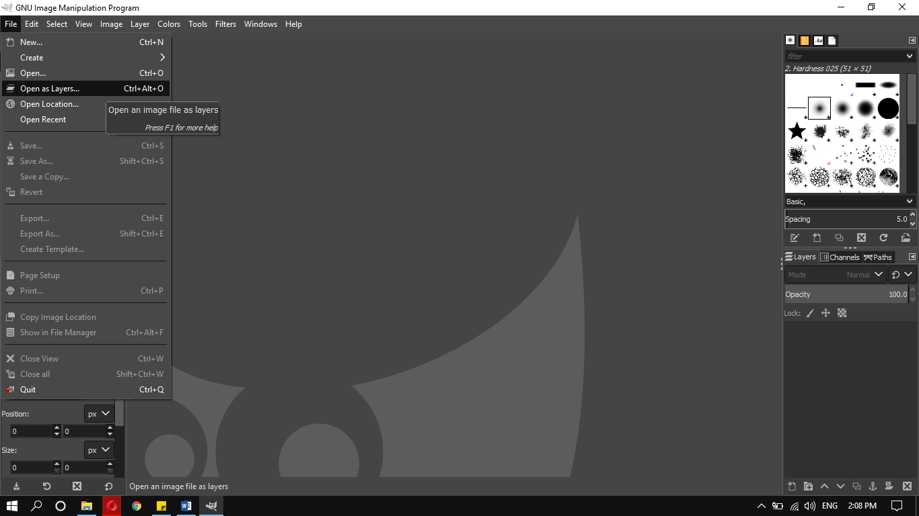

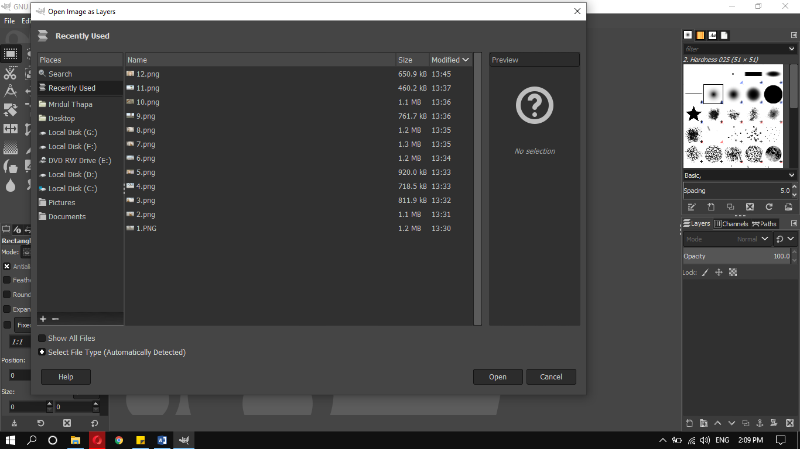

**Step3:** After opening all the pictures as layers, go to **EXPORT AS** and save the picture in any folder of your choice using the extension **.GIF**.

The Export Image as GIF dialog box pops up, export it as animation. Set the delay between frames of your choice in milliseconds, it means the time delay between the pictures.

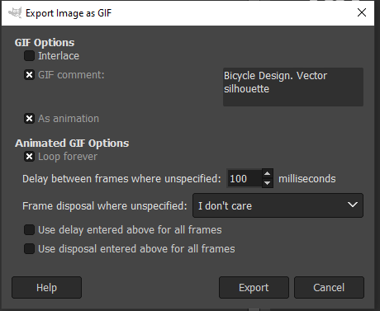

**Step4:** The saved file with the extension of .GIF is now saved and the pictures now work with the delay we set on the export dialog box.